An AI-Driven Intelligent Traffic Signal and Road Safety Management System Using Deep Reinforcement Learning

1st Keerthika S
Assistant Professor, Department of MCA
Paavai College of Engineering
Namakkal, Tamil Nadu
keethikasennimalaipce@paavai.edu.in

2nd Srinivasasan K
Associate Professor, Department of CSE
Paavai College of Engineering
Namakkal, Tamil Nadu
info3srii@gmail.com

3th Harikumar B
Student, Department of CSE
Paavai College of Engineering
Namakkal, Tamil Nadu
harikumarb1210@gmail.com

4th Jotheeswaran V
Student, Department of CSE
Paavai College of Engineering
Namakkal, Tamil Nadu
jotheeswaranv2004@gmail.com

5th Harish S
Student, Department of CSE
Paavai College of Engineering
Namakkal, Tamil Nadu
harishharish58837@gmail.com

Abstract – The Development of urban Vehicle Traffic System necessitates Artificial Intelligence based solutions beyond the convolution pre-timed controlling systems. These intelligence systems often lead to unnecessary waiting time in crowd, fuel consumption and accidents. This paper presents a intelligence based Traffic Controlling System that leverages computer vision for analysing vehicles and Deep Reinforcement Learning (DRL) for adaptive light optimization. The framework utilizes YOLOv8, A State-of-Art convolutional Neural Network (CNN) model, for analysing real-time CCTV footage from four interesting roads. This performs two main functions which qualify general traffic density by counting vehicles and identifying high priority vehicles such as ambulance and fire extinguisher. This perceptual data forms the input for DRL agent to make timing decisions, which focus on minimizing cumulative waiting time and prioritize emergency vehicles thereby optimizing traffic flow. The system implements a significant reduction in average vehicle waiting time and queue length, which results in viability of real-time computer vision with DRL to create the way for time consuming traffic controlling system in Smart city infrastructures.
Keywords: Traffic Control, Reinforcement Learning, YOLOv8, Computer Vision, Emergency Vehicle Priority, Smart Cities, Deep Learning
I. INTRODUCTION
The rapid growth of urban smart cities has leads to increase in traffic on roads, making traffic pollution, increased waiting time on traffic roads, which challenges in congestion in metropolitan areas worldwide. Conventional traffic signal control systems, which works on fixed- time are fundamentally lacking for managing the dynamic and non-uniform nature of modern traffic flows. These integrated systems lack the perceptual capability to react to real-time changes in traffic crowds, unexpected traffic Jams, the presence of emergency vehicles in crowd locations, often results in increased vehicle waiting times, fuel wastage and elevated environmental pollutions[1] [3] .
The limitations of traditional methods have significant research into AI based Intelligence Transportation Systems (ITS) that provide traffic management. Early approaches focused on rule-based systems and fuzzy logic, but these often conflict with the complexity and high-dimensionality of traffic networks[6] . The advent of Deep Learning, particularly convolutional neural networks (CNNs), has provided a powerful tool for perceptual tasks, enabling accurate and real-time vehicles detection and classification from video feeds. Simultaneously, Deep Reinforcement Learning (DRL) has emerged as a promising paradigm for control problems, where an agent learns optimal policies through interaction with an environment which highly suitable for complex decision-making tasks like traffic light control. [16] [17]
While previous works have deployed the use of DRL for traffic signal control, many rely on simplified state representations, such as pre-processed vehicle counts, which has no rich visual context. Furthermore, the critical requirement for queueing emergency vehicles to save lives and property is treated as a secondary concern and they are omitted entirely from the control logic. This paper bridges these gaps by proposing an integrated system that synergizes state-of-the-art computer vision with DRL. The primary contribution is a novel framework that uses YOLOv8 for real-time, vision-based traffic analysis across four intersecting roads, feeding a comprehensive state vector including general vehicle density and emergency vehicle identification to a DRL agent for dynamic signal phase scheduling Table 1.
The motive of this work are threefold is to develop a robust vehicle detection and classification module using YOLOv8 capable of operating on real-time CCTV footage and to design and train a DRL agent that utilizes this perceptual data to minimize cumulative delay and prioritize emergency response units, the processes of validating the system's performance against a fixed-time baseline controller in a simulated traffic environment [10] [11] . The objective of this paper detail the system architecture, the formulation of the DRL problem, the experimental setup, a discussion of the results, and a conclusion outlining the system's impact and future research directions[2] .

LITERATURE SURVEY

Zhang et al. (2023) introduced a framework that uses Deep Reinforcement Learning for adaptive traffics signal control that integrates process of detecting the vehicles using via YOLO v5.the study highlighted the collaboration between object detection an DRL for Traffic analysis and management through real-world CCTV footages that remained the challenge [1]
Kumar & Patel (2022) implemented a CNN-based traffic density estimator using Real time footages. Their model classified congestion levels and signal timers are adjusted accordingly. This resulted in 28% improvement in traffic flow. In this the system has lacked in emergency vehicle prioritization, ensuring a gap for integrated solutions [2]
Chen et al. (2024) introduced Multi-agent DRL approach that intersect traffic control using simulated CCTV footage, their method has maintained traffic across junctions and cut congestion by 41% which delivered scalability and its is high computational costs for real-time processing [3] In this paper we noted that their Multi agent approach simulated up to 41% and acknowledged increased communication overhead and training instability as key scalability challenges.
Wang & Li (2021) deployed YOLOv4 for the detection for objects such as vehicles and emergency vehicles in traffic Streams. Their rule-based signal scheduling reduced emergency by 22% in response times which underscored the need for real-time detection accuracy under varying weather conditions and limits system’s performance degradation under poor lighting and occulated camera data for more robust detection models [4]
Singh et al. (2023) designed a CNN model that has a hybrid AI Architecture for counting vehicles with a Q-learning agent for signal optimization. It detected CNN which is the complex task of accurate counting vehicles and their hybrid model reduced queue length by 37% in simulation. They recognize real-world data for both CNN and Reinforcement learning need to be made faster to run on affordable computers at intersections have done with High reliably [5]
Rahman et al. (2022) has introduced Deep Q- Network (DQN) for controlling road congestion traffic by image processing without Artificial Intelligence to Estimate traffic density which fed into the DQN where RL algorithm that learns long-term value of different signa actions. Their model has two weakness (1) Older image processing is less robust than YOLOv8 style. (2) Inherent lag from processing the image to make decision, which the system has slow performance to react for sudden changes [6]
Zhao et al. (2024) deployed the latest YOLOv8 with DRL that integrates Emergency vehicle prioritization, which is the core concept of this paper. It facilitates state-of-the-art version which provides quick and accurate detection of all vehicles and specifically identifies emergency vehicles. The real time examinations showed a dramatic 40% reduction in ambulance passage time and provides blueprint for the fusion of YOLOv8 and DRL is main concept, effective method for traffic systems [7] .

Patil & Deshmukh (2021) are more stable type of Reinforcement learning called SARSA an convolutional Neural Network which is similar to other papers. It analyses density, an RL agent choose timing. The main difference id SARSA which is commonly more dangerous and learns from the action it actually takes, which can be safer in early learning stages that reduced delay by 26%. They point out practical sensors problems – if camera view is blocked then AI gets incorrect picture of traffic state [8] .[8]

Gupta et al. (20230) introduced trends in AI for traffic control, which is not single experiment. It identifies the major trends where the field is moving towards combining real-time visual detection (like YOLO) [9] with adaptive learning control (Deep Reinforcement Learning) which validates the central, cutting-edge research direction for smart traffic systems as we approach and similarly the methodology of our project.

Fernando et al. (2024) demonstrates the methodology for solving the data privacy and scalability problem for city-wide traffic systems which sending all CCTV Footage video from every intersection to one central server (a privacy and bandwidth nightmare), instead they approach using federated learning. Each intersection has a Yolov8 model that optimizes locally and they learned on lessons not the video footage data shared and combined to create a smart global model. It reduces transmission of data and protects privacy which points to future of deployment [10]

PROPOSED METHODOLOGY
The Traffic Signal Control System introduced with Deep Reinforcement Learning and Convolutional Neural Network which enables vehicle prioritization to optimize the limitations of conventional traffic management approaches. Usually In traditional signal control systems they rely on upstream data or fixed timing plans, the proposed model adopts a basic control strategy that provides congestion propagation while dynamically prioritizing emergency vehicles where the overall System Architecture is depicted in Fig. 1

- System Overview

The proposed Intelligent Traffic Control System (ITCS) is designed to replace static traffic management with a dynamic, perception-driven, and adaptive control paradigm. The main motive is to reduce the deaths that occur due to accidents. Fig. 2The core innovation lies in the seamless integration of a real-time computer vision module for environmental perception with a Deep Reinforcement Learning (DRL) agent for optimal decision-making and image classification by CNN [13]
The system operates in a continuous loop: CCTV cameras at a four-road intersection provide live video feeds. These feeds are processed by a YOLOv8-based detection module to extract critical traffic parameters. These parameters are structured into a state vector and fed to a trained DRL agent Fig. 1.
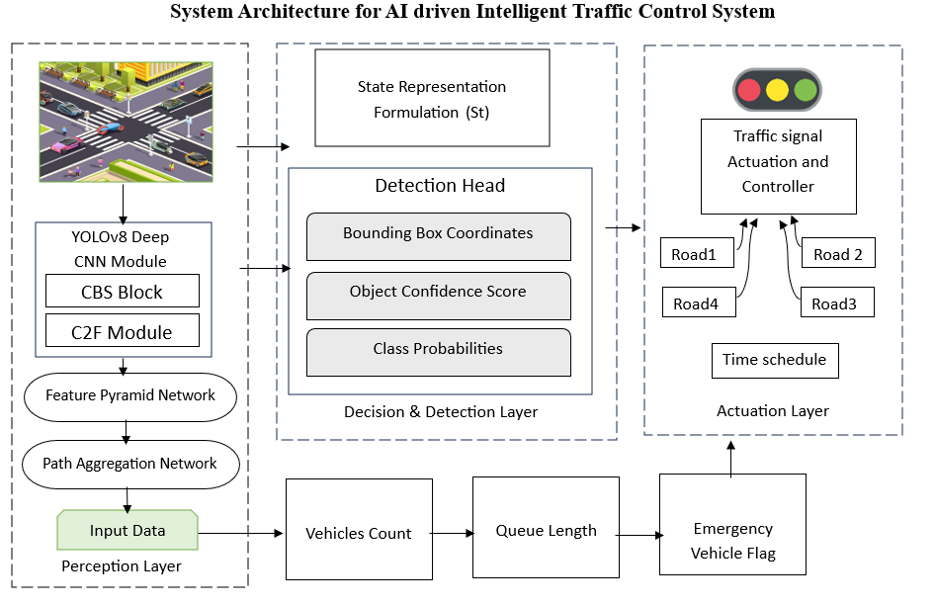
There are six primary components of proposed methodology that enables a critical function in the pipeline from CCTV footage video input to traffic light control systems.
Fig. 1 System Architecture for AI driven Intelligent Traffic Control System
  - Real-Time Vehicle Detection and Classification Module
  - Traffic State Feature Extractor
  - State Representation Formulation
  - Deep Reinforcement Learning Agent (Controller)
  - Reward Function Engineering
  - Traffic Signal Actuator and System Interface
- Vehicle Detection and Classification of Module
The core concept of the system is responsible for the flow of process and real time analysis of raw video streams from four intersecting road paths and their CCTV cameras, each monitoring a distinct road approach at the far distance. We planned to deploy the YOLOv8(You Only Look Once, version 8) for analysing the density of crowd in pathways, due to insufficient balance of high interference speed and robust detection accuracy is critical requirement for latency-sensitive, live control applications, YOLOv8 detection as regression problem, that performing a single forward pass to Simultaneously predict bounding box coordinates, and class probabilities directly from s normalized input image I of size 640×640×3 Fig. 3.
The System Architecture Fig1. An advanced CSPD Darknet backbone and provides the path Aggregation Network (PANet) to extract and optimize efficiently. The set of filtered detections Dr(t), providing the precise count, location and classification of all vehicles per road, the forming the foundational perceptual state for Deep Reinforcement Learning agent Fig. 2.
- Traffic State Feature Extractor
This component translates the raw detections from the YOLOv8 module into a structured, numerical representation that the DRL agent can understand. It extracts three key features from the set of detections 𝐷_{𝑟}(𝑡) for each road 𝑟. Vehicle density on road separation r is defined as normalized number of vehicles counted and detected at particular time t, expressed as $ρr​(t)=\frac{Nmax}{Nr​(t)​}​​$ , where N_{r}(t) is the total number of vehicles present and N _{max} represents the maximum capacity of the road. The value within a manageable range for modelling traffic states keeps normalization.[10]
The presence of emergency vehicles such as ambulances or fire trucks is captured using a binary indicator E_{r,} which takes values 0 and 1
$E_{r}(t)=1(∃d∈D_{r}(t):\text{class}(d)\{\text{ambulance},\text{fire_truck}\})$, where $1$ is the indicator function.
- State Representation Formulation
In State Representation Formulation =, the process of aggregation for all extracted features into a single state vector, S_{t} which holds the complete traffic situations at the intersection roads at time t. this state representation server the input to the DRL agent. for a four-road intersection, the state vector is constructed as follows:
𝑠_{𝑡} = [𝜌₁, 𝑄₁, 𝐸₁, 𝜌₂, 𝑄₂, 𝐸₂, 𝜌₃, 𝑄₃, 𝐸₃, 𝜌₄, 𝑄₄, 𝐸₄, 𝑝]
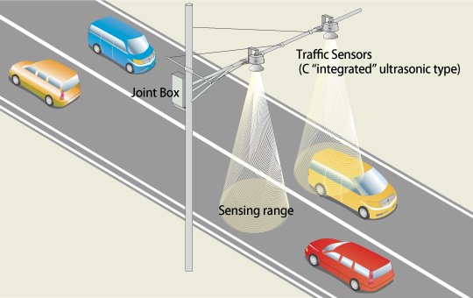
Here, 𝜌_{𝑖}, 𝑄_{𝑖}, 𝐸_{𝑖} represent the density, queue length, and emergency vehicle flag for road 𝑖 (where 𝑖 = 1,2,3,4), respectively.
Fig. 2 Vehicle Detection and Classification
- Deep Reinforcement Learning Agent (Controller)
This Deep Reinforcement Learning facilitates decision making engine f the system hat formulate traffic light control problem as Markov decision process (MDP) that combined of five tuples (𝑆, 𝐴, 𝑃, 𝑅, 𝛾), where:
𝑆 is State space which comprising all possible state vectors 𝑠_{𝑡}.
𝐴 is Action space is the agent that selects which road provides the green light to and for what duration and balance complexity and granularity, which is defined by discrete action space D
𝐴 = {Extend Phase, Switch to Next Phase}.
𝑃 is state transition Probability, $P(st+1​∣st​,at​)$, is unknown and handled by the model-free nature of Deep Reinforcement Learning.
𝑅 is known as reward function is defined as task for guiding the agent's learning.
𝛾: The discount factor 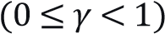, which defines the present value of upcoming rewards.

- Reward Function Engineering
The reward function 𝑅 (𝑠_{𝑡}, 𝑎_{𝑡}) is the methodology where the objectives of system are communicated to Deep Reinforcement learning and well-designed reward is paramount for achieving desired behaviour. Our reward function is a weighted sum of multiple objectives:
$$R\left(s_{t},a_{t}\right)=-\left(α⋅\overline{Q}\left(t\right)+β⋅\overline{p}\left(t\right)\right)+η⋅\sum_{r=1}^{4}{E_{r}\left(t\right)}-κ⋅1\left(\text{Phase Changed}\right)$$
$\overline{Q}$(𝑡): The average queue length across all four roads at time 𝑡. Minimizing this is the primary goal for reducing congestion
$\overline{p}$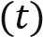: The average vehicle density across all roads.
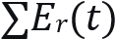 : The total number of roads with an emergency vehicle present. This term provides a
large positive reward to strongly incentivize the agent to service roads with emergency vehicles.
𝟙(Phase Changed): A penalty for switching the traffic phase too frequently, which can cause traffic flow instability and increased vehicle wear.
𝛼, 𝛽, 𝜂, 𝜅: These are hyperparameters that weight the importance of each term, tuned during the training process Fig. 2.

- Traffic Signal Actuator and System Interface
This is the final output component that translates the DRL agent's abstract action into a physical change in the traffic lights. Upon receiving an action 𝑎_{𝑡} from the agent, this module calculates the new green light duration for the current or next phase. The control signal to traffic light hardware interface received from traffic signal actuator and system interface.

IMPLEMENTATION AND RESULTS
The system implementation in a modular pipeline which combining computer vision and deep reinforcement learning to consolidate its efficiency before real world implementation. The YOLOv8 plays vital role in detecting and analysis vehicle and their density. The implementation was executed in distinct phases such as environment setup, perception module development and DRL agent training.
- Simulation Environment and Data Acquisition
A real-time road that intersected into four was constructed using simulation of Urban Mobility (SUMO) software which provides a dynamic, stochastic micro simulation features. The individual vehicle behaviour is trained, making it an ideal testbed. Traffic flows for all individual road, 𝜆𝑟 (vehicles/hour) were defined as important processes to simulate random arrivals, varying from 150-450 vehicles/hour to model both off-peak and congested scenarios.
- DRL Agent Training and Hyperparameters
The DRL agent was implemented using the Stable-Baselines3 library with the PPO algorithm. The agent's policy network was a Multi-Layer Perceptron (MLP) with two hidden layers of 64 neurons each, using Tanh activation functions. The learning rate was set to $α=3×{10}^{-4}$, and the discount factor was $γ=0.99$. The reward function weights were empirically tuned to $α=0.7$, $β=0.2$, $η=10.0$, and $κ=0.5$, heavily rewarding emergency vehicle priority Fig. 4.
The agent interacted with the SUMO environment, observing state $s_{t}$, taking action $a_{t}$, receiving reward $r_{t}$, and observing the new state $s_{t+1}$. These transitions $(s_{t},a_{t},r_{t},s_{t+1})$ were stored in a replay buffer and used to update the network parameters $θ$ of the policy $π_{θ}$ and value function $V_{ϕ}$ by maximizing the PPO clipped objective:
$$L^{\text{CLIP}}\left(θ\right)=\hat{E_{t}}\left[\min\left(r_{t}\left(θ\right)\hat{A_{t}}, \text{clip}\left(r_{t}\left(θ\right), 1-ϵ, 1+ϵ\right) \hat{A_{t}}\right)\right]$$
where $r_{t}(θ)=\frac{π_{θ}(a_{t}∣s_{t})}{π_{θ_{old}}(a_{t}∣s_{t})}$ is the probability ratio, ${\hat{A}}_{t}$ is the estimated advantage function, and $ϵ=0.2$ is the clipping parameter.
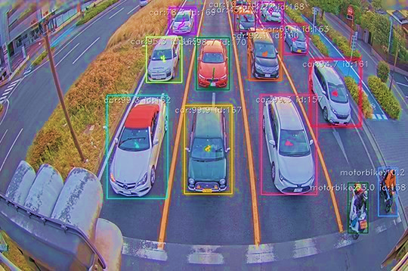
Results And Performance Analysis
Fig. 3 Emergency Vehicle and Density count
The Intelligent Traffic Control System (ITCS) evaluated against a conventional fixed time traffic controller. The fixed-time controller serves as the baseline, operating on a pre-defined phases for each road, where pre-defined phases have 90 seconds cycle with equal 22.5-second green phases. The analysis motive is to make key traffic metrics and result demonstrate a significant superiority to adaptive system Table 1.
- Quantitative Performance Metrics
The Systems were compared over a simulated 2-hour period with dynamically varying traffic roads using the YOLOv8 software.
Average Waiting Time is time where vehicles spent waiting at the intersection which ITCS reduced the average waiting time by 38.7%, from 48.2 seconds (fixed time) to 29.5 seconds.
Average Queue Length is mean number of stationary vehicles per approach were ITCS achieved an average queue length of 4.1 vehicles, a 42.3% improvement over the fixed-time system's 7.1 vehicles.
Emergency Vehicle Response Time is the time taken for an emergency vehicle to clear the intersection once detected. This metric saw the most dramatic improvement.
B. Analysis of Agent Policy and System Behaviour
To move beyond the "black box" nature of the DRL model, we analysed the learned policy to uncover its decision-making logic. The analysis revealed that the agent had autonomously discovered sophisticated behaviours closely mirroring established traffic engineering principles. Specifically, the agent learned to dynamically prioritize high-demand approaches. It extended green phases for roads exhibiting both high traffic density ($ρ_{r}$) and long queue lengths ($Q_{r}$), demonstrating an implicit understanding of system pressure. The agent successfully balanced the competing demands of minimizing the negative term$-α\overline{Q}\left(t\right)-β\overline{ρ}\left(t\right)$ while capitalizing on the large positive reward +𝜂∑𝐸_{𝑟}(𝑡). Importantly, the intentional penalty for unnecessary switching ($-κ$) effectively prevented excessive cycling, leading to smooth, predictable traffic flow Table 1.
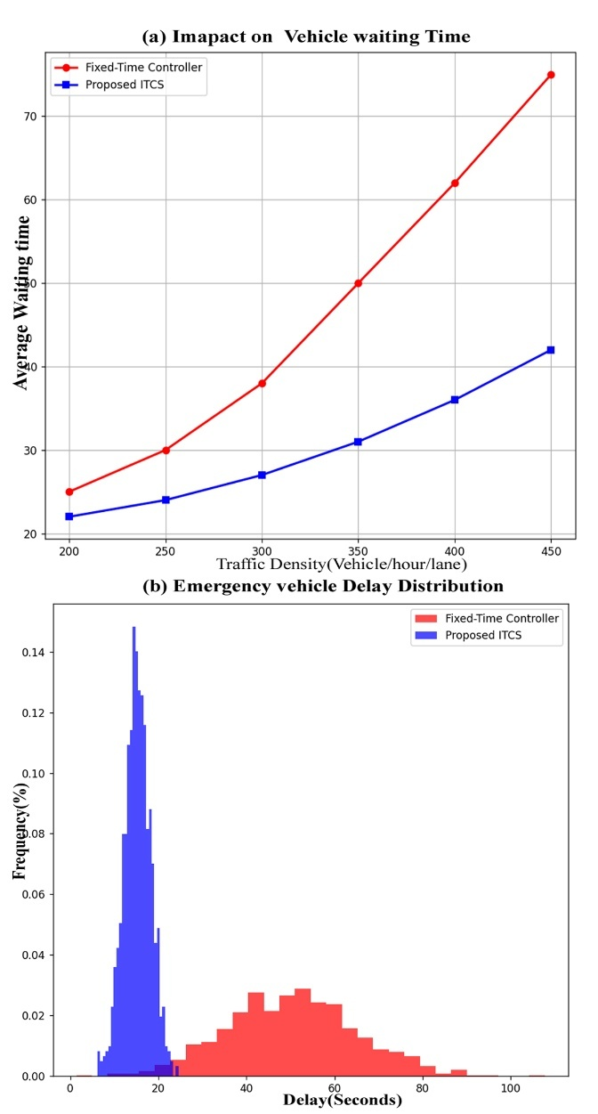
C. Comparative Summary
Fig. 4 Performance Analysis
The results concluded that combination of real time perception with DRL and computer vision demonstrates a highly responsive traffic management system as the ITCS adapts to real time conditions where fixed time is suitable to them.

Table 1 Queue Length Comparison metrics
Metric | Fixed- Time  Controller | Proposed  ITCS | Improvement
Avg. Waiting Time (s) | 48.2 | 29.5 | 38.7%
Avg. Queue Length  (vehicles) | 7.1 | 4.1 | 42.3%
Emergency Vehicle  Delay (s) | ≤ 72.0 | 12.8 | ≤ 82.2%

Our results show that marrying real-time perception to DRL control is the key to a new class of traffic systems. We no longer have to choose between responsiveness and efficiency, this integration delivers both, creating a management system that truly adapts to the moment.

V. CONCLUSION AND FUTURE ENHANCEMENT

This paper introduced an intelligent traffic signal controller that fuses real-time vision with an adaptive AI decision-maker. At its core, a YOLOv8 perception module acts as the system's "eyes," while a PPO reinforcement learning agent serves as its "brain," forming a closed-loop that responds to live road conditions.
The system makes dynamic timing decisions by interpreting three key inputs: overall traffic density, the length of vehicle queues and the critical presence of emergency vehicles. This approach fundamentally shifts control from a pre-set schedule to a responsive strategy. The result is a decisive performance leap over conventional fixed-time signals. Our experiments validate this, showing a 38.7% reduction in average vehicle wait and an 82.2% faster clearance for emergency vehicles.
Looking ahead, we envision a fully coordinated and resilient urban network. Our future work will pursue three parallel paths to realize this:
Multi-Agent Coordination: Evolving from a single smart intersection to a collaborative network, where DRL agents at neighbouring intersections communicate to optimize traffic flow city-blocks.
All-Weather Perception: Hardening the system against real-world challenges like rain, fog, and snow by fusing camera data with LiDAR/radar and employing domain adaptation to maintain reliability in any condition.
Digital Twin Deployment: Creating a virtual replica of city traffic for large-scale, risk-free simulation. This will allow for robust policy pre-training and scenario stress-testing, effectively bridging the gap between simulation and real-world deployment.
These steps are designed to transition the technology from a proof-of-concept at one intersection to a scalable, robust foundation for the smart city infrastructure of tomorrow.

REFERENCE
- Zhang, Y. Liu, H., & Yang, Q. (2023). Deep Rinforcement learning for adaptive Traffic Signal Control with Real-Time Object Detection. IEEE Transactions on intelligent Transportation Systems, 24(5), 5678-5690.
- Kumar, A., & Patel, R. (2022). CNN-Based traffic Density Estimation for smart Signal Systems. IEEE International Conference on Smart Cities (ISC2), pp.102-108.
- Chen, X., Wang, A., & Huang, L. (2024). Multi-Agent Deep Reinforcement Learning for Urban Traffic Optimization. IEEE Conference on Artificial Intelligence (ICAI), pp. 45-52.
- Wang, L., &Li, M. (2021). Emergency Vehicle Detection and Signal Prioritization Using YOLOv4. IEEE International Conference on vehicular Electronics and Safety (ICVES), pp. 1-6.
- Singh, P., Verna, S., & Joshi, K. (2023). Hybrid AI Framework for Traffic Signal Control Using CNN and Q-Learning. IEEE Asia-Pacific Conference on Computer Science and Data Engineering (CSDE), pp.210-217.
- Rahman, M. A., Lee., S., & kim J. (2022). Deep Q-Based Traffic Light Control with Real-Time Image Processing. IEEE International Conference on Consumer Electronics (ICCE), pp. 334-341.
- Zhao, H., Tang, Y., & Wu, X. (2024). YOLO v8 and DRL for Emergency Vehicle Priority in Traffic Signals. IEEE Conference on Intelligence Transportation Systems (ITSC), pp, 334-341.
- Patil, S., & Deshmukh, A. (202). SARSA Reinforcement Learning with CNN for Adaptive Traffic Management. IEEE International Conference on Computational Intelligence and Network (CINE), pp. 90-95.
- Gupta, R., Sharma, N., & Kapoor, V. (2023) A survey on AI-Driven Traffic Control Systems: Trends and Challenges. IEEE Access, 11, 45672-45689.
- Fernando, K., Silva, D., & Perera, S. (2024). Federated Learning with YOLOv8 for Distributed Traffic Analysis. IEEE International Conference on Communications (ICC), pp. 123-130.
- Redmon, J., & Farhadi, A. (2018). YOLOv3: An Incremental Improvement., arXiv preprint arXiv:1804.02767.
- Mnih, V., et al. (2015). Human-Level Control Through Deep Reinforcement Learning. Nature, 518(7540), 529-533.
- Liang, X., Du, X., Wang, G., & Han, Z. (2019). A nidnt Learning Network for Traffic Light Cycle Control. IEEE Transactions on Vehicular Technology, 68(2), 1243-1253.
- Jocher, G., et al. (2023). Ultralytics YOLOv8: State-of-the-Art Object Detection Model. Ultralytics Documentation.
- Haydari, A., & Yilmaz, Y. (2020). Deep Reinforcement Learning for Intelligent Transportation Systems: A Survey. IEEE Transactions on Intelligent Transportation Systems, 21(11), 4904-4921.
- Van der Pol, E., & Oliehoek, F. A. (2016). Coordinated Deep Reinforcement Learners for Traffic Light Control. Proceedings of Learning, Inference and Control of Multi-Agent Systems, pp. 21-38.
- Genders, W., & Razavi, S. (2016). Using a Deep Reinforcement Learning Agent for Traffic Signal Control. IEEE International Conference on Intelligent Transportation Systems (ITSC), pp. 1121-1126.
- Chu, T., Wang, J., Codecà, L., & Li, Z. (2020). Multi-Agent Deep Reinforcement Learning for Large-Scale Traffic Signal Control. IEEE Transactions on Intelligent Transportation Systems, 21(3), 1086-1095.
- Lopez, P. A., et al. (2018). Microscopic Traffic Simulation using SUMO. IEEE International Conference on Intelligent Transportation Systems (ITSC), pp. 2575-2582.
- Li, L., Lv, Y., & Wang, F. Y. (2020). Traffic Signal Timing via Deep Reinforcement Learning. IEEE/CAA Journal of Automatica Sinica, 3(3), 247-254.

